

**Sri Lanka Institute of Information Technology**[SE3030 - Software Architecture [2025/FEB]](https://courseweb.sliit.lk/course/view.php?id=6089)

**ASSIGNMENT 01**

# OSGI FRAMEWORK FOR PAINT SHOP

**Submitted by**

|  |  |  |  |
| --- | --- | --- | --- |
| **Name** | **REGISTRATION NUMBER** | **Status** | **Batch** |
| Senarathne S M A D | IT20089436 | Pro-rata | Weekend |

Git Hub Repository Link : <https://github.com/amila1998/OSGI_FrameWork-Paint-Shop>

Contents

OSGI FRAMEWORK FOR PAINT SHOP 1

INTRODUCTION 5

RELATIONSHIP DIAGRAM 6

WORKFLOWS 7

CUSTOMER WORKFLOW 7

ADMIN WORKFLOW 8

DRIVER WORKFLOW 9

MANIFEST IMPLEMENTATION (EXPORTED SERVICES / IMPORTED SERVICES) 10

ADMIN PRODUCER 10

MIXER PRODUCER 10

ORDER PRODUCER 11

DELIVERY PRODUCER 11

CUSTOMER PRODUCER 12

ADMIN CONSUMER 12

CUSTOMER CONSUMER 13

DELIVERY CONSUMER 13

ALL COMMANDS OF BUNDLE INSTALL AND RUN IN OSGI FRAMEWORK 14

Running the OSGi Bundles Without Exporting JARs (Directly from Eclipse) 14

Running the Exported OSGi JAR Bundles 20

Figures

Figure 1: OSGI Architecture 4

Figure 2: OSGI Behaviors 4

Figure 3: System Publisher and Subscriber Diagram 5

Figure 4: System Publisher and Subscriber Diagram - Relations 6

Figure 5: customer workflow 7

Figure 6: Admin Workflow 8

Figure 7: Driver Workflow 9

Figure 8: Admin producer manifest 10

Figure 9: Mixer producer manifest 10

Figure 10: Order producer manifest 11

Figure 11: Delivery producer manifest 11

Figure 12: Customer producer manifest 12

Figure 13: Admin consumer manifest 12

Figure 14: Customer consumer manifest 13

Figure 15: Delivery consumer manifest 13

Figure 16: Run Configurations 14

Figure 17: Verify Bundles 15

Figure 18: Admin Workflow Output SS 16

Figure 19: Admin Workflow Output SS 16

Figure 20: Admin Workflow Output SS 17

Figure 21: Admin Workflow Output SS 17

Figure 22: Customer Workflow Output SS 18

Figure 23: Customer Workflow Output SS 18

Figure 24: Customer Workflow Output SS 19

Figure 25: Driver Workflow Output SS 19

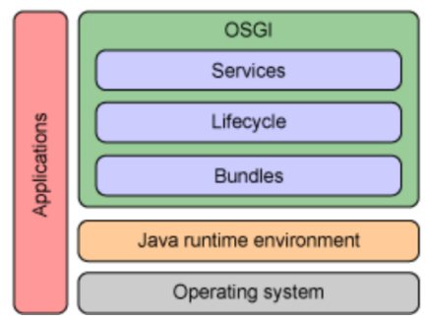

Figure 1: OSGI Architecture

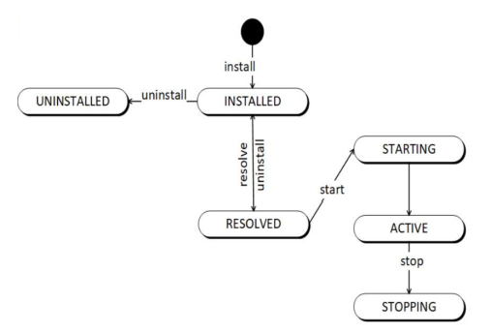

Figure 2: OSGI Behaviors

## INTRODUCTION

This system is designed to efficiently manage a paint shop. Customers can sign up and log in to browse and place orders for paints. Additionally, they have the option to choose whether their orders should be delivered.

The system also includes administrative functionality, allowing administrators to create new paints and manage delivery user accounts. Delivery users can log in to view a list of pending delivery orders and process them accordingly.

Leveraging the power of the OSGi (Open Service Gateway Initiative) framework, this system provides a modular and dynamic architecture, ensuring efficient management and seamless delivery of services.

* Admin Producer
* Customer Producer
* Delivery Producer
* Mixer (Paint) Producer
* Order Producer

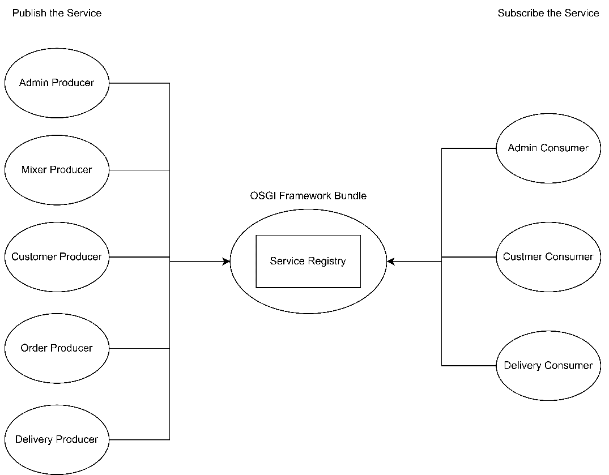

Figure 3: System Publisher and Subscriber Diagram

### RELATIONSHIP DIAGRAM



Figure 4: System Publisher and Subscriber Diagram - Relations

## WORKFLOWS

### CUSTOMER WORKFLOW



Figure 5: customer workflow

### ADMIN WORKFLOW



Figure 6: Admin Workflow

### DRIVER WORKFLOW



Figure 7: Driver Workflow

## MANIFEST IMPLEMENTATION (EXPORTED SERVICES / IMPORTED SERVICES)

### ADMIN PRODUCER

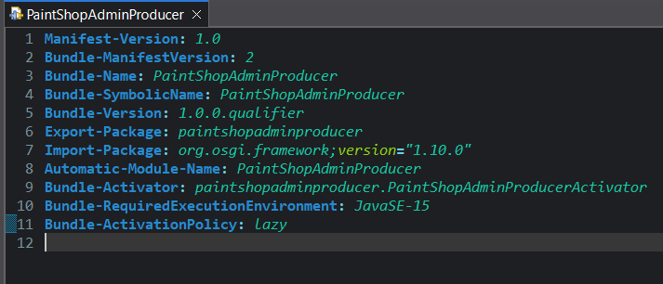

Figure 8: Admin producer manifest

### MIXER PRODUCER

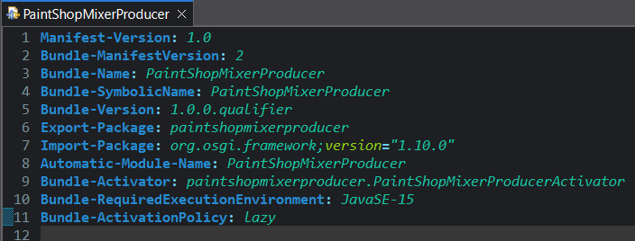

Figure 9: Mixer producer manifest

### ORDER PRODUCER

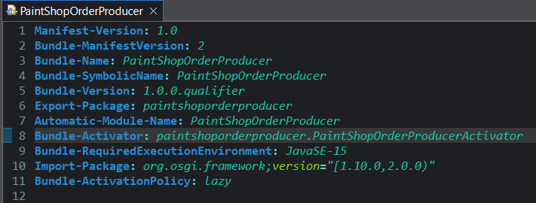

Figure 10: Order producer manifest

### DELIVERY PRODUCER

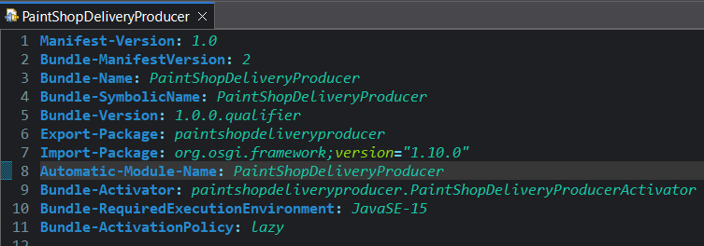

Figure 11: Delivery producer manifest

### CUSTOMER PRODUCER

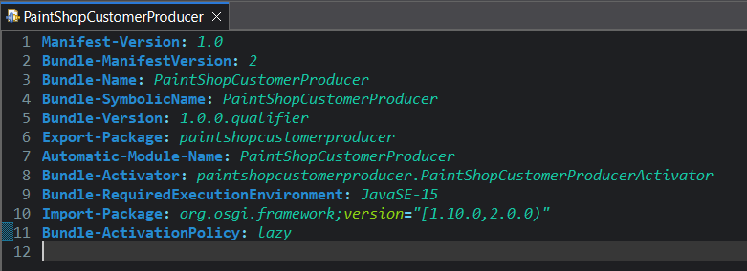

Figure 12: Customer producer manifest

### ADMIN CONSUMER

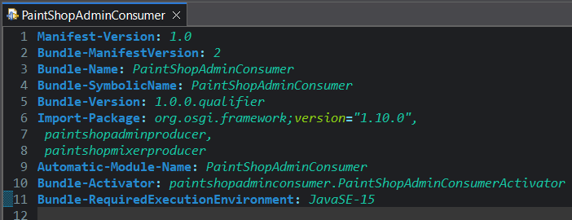

Figure 13: Admin consumer manifest

### CUSTOMER CONSUMER

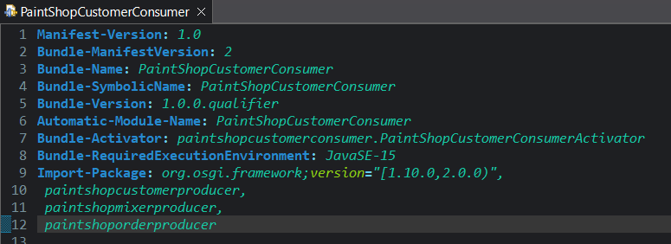

Figure 14: Customer consumer manifest

### DELIVERY CONSUMER

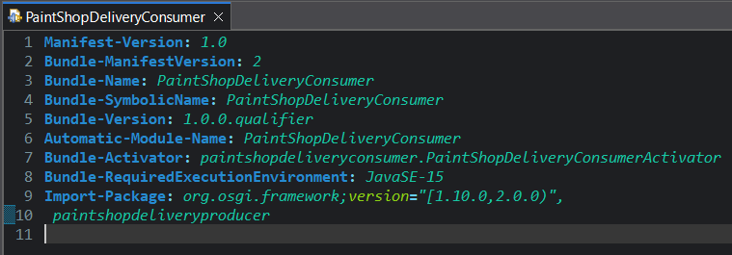

Figure 15: Delivery consumer manifest

## ALL COMMANDS OF BUNDLE INSTALL AND RUN IN OSGI FRAMEWORK

Make sure you have Equinox OSGi installed

### Running the OSGi Bundles Without Exporting JARs (Directly from Eclipse)

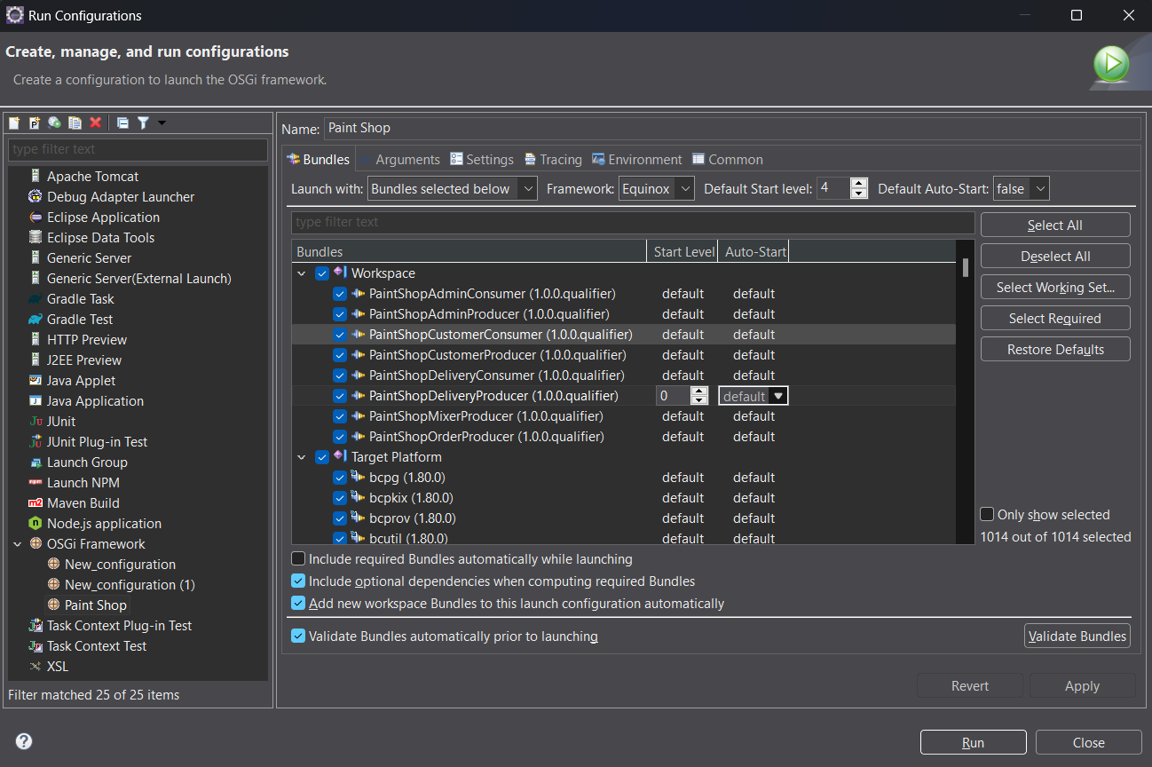

Figure 16: Run Configurations

#### Step 1: Open "Run Configurations" in Eclipse

1. Click on Run → Run Configurations.
2. Select OSGi Framework from the left panel.
3. Ensure all required bundles are selected (as shown in Figure 16: Run Configurations).

#### Step 2: Configure the OSGi Framework

1. Framework: Ensure Equinox is selected.
2. Auto-Start: Set false for all Producer and Consumer bundles.
3. Validate Bundles: Click on Validate Bundles to ensure dependencies are resolved

#### Step 3: Run the OSGi Framework

1. Click Apply → Run.
2. Eclipse will start the OSGi framework and execute the bundles.
3. Open the Eclipse Console to view logs/output

#### Step 4: Verify Running Bundles

1. After launching, Open the OSGi console in Eclipse.
2. Type: lb or ss

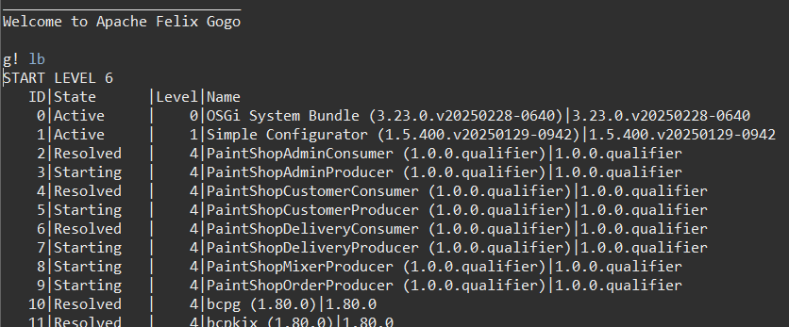

Figure 17: Verify Bundles

##### Admin Workflow

1. To Run Type: start 2
2. To Stop Type: stop 2

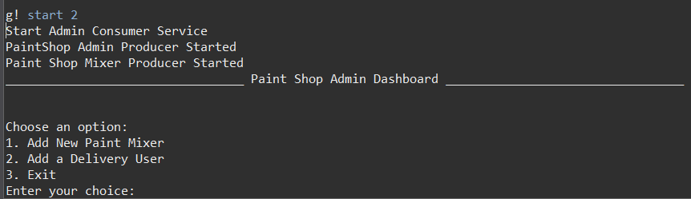

Figure 18: Admin Workflow Output SS

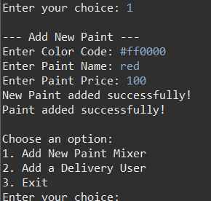

Figure 19: Admin Workflow Output SS

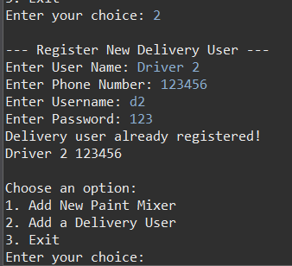

Figure 20: Admin Workflow Output SS

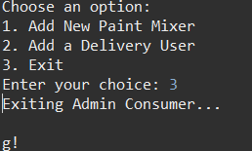

Figure 21: Admin Workflow Output SS

##### Customer Workflow

1. To Run Type: start 4
2. To Stop Type: stop 4

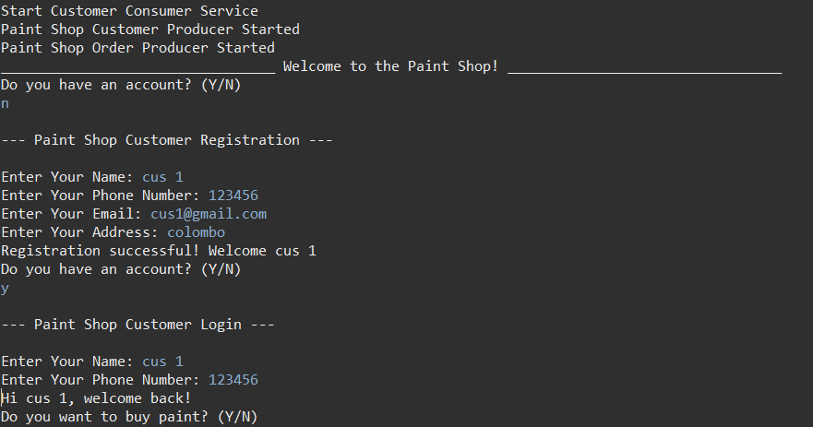

Figure 22: Customer Workflow Output SS

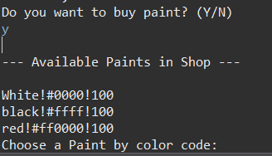

Figure 23: Customer Workflow Output SS

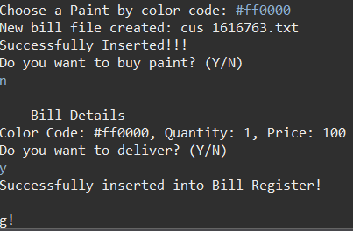

Figure 24: Customer Workflow Output SS

##### Driver Workflow

1. To Run Type: start 6
2. To Stop Type: stop 6

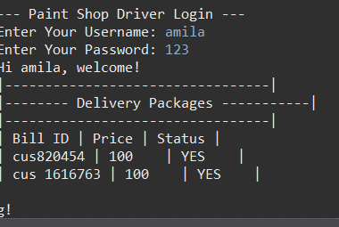

Figure 25: Driver Workflow Output SS

### Running the Exported OSGi JAR Bundles

#### Step 1: Open Terminal / Command Prompt and Navigate to the Directory

Type: cd /path/to/JAR

*Replace with the actual path, where you saved your JAR files.*

#### Step 2: Start the OSGi Framework

Run the Equinox OSGi framework launcher:

Type: java -jar org.eclipse.osgi_VERSION.jar -console

*Make sure to replace org.eclipse.osgi_VERSION.jar with the actual name of your Equinox JAR.*

#### Step 3: Install All Bundles

Inside the OSGi console, install each JAR file:

Type:

* install file:Admin\ Consumer.jar
* install file:Admin\ Producer.jar
* install file:Customer\ Consumer.jar
* install file:Customer\ Producer.jar
* install file:Delivery\ Consumer.jar
* install file:Delivery\ Producer.jar
* install file:Mixer\ Producer.jar
* install file:Order\ Producer.jar

#### Step 4: Continue from This